Attachment B - Site Map
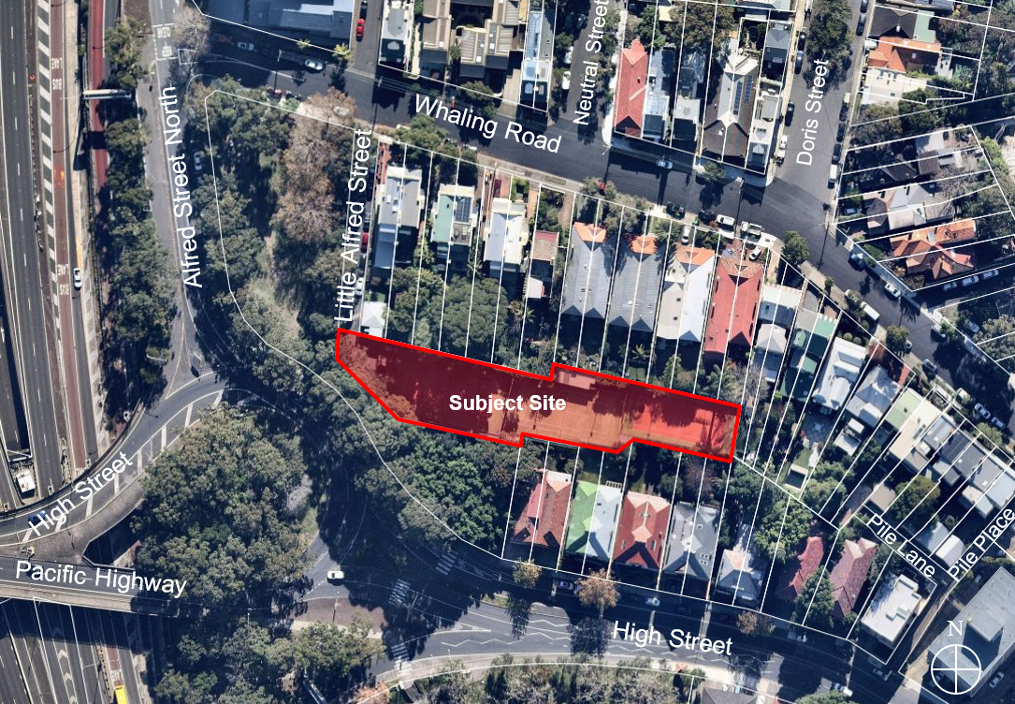
N
Figure 1: Subject site (source: Nearmap)

